stream: CBSE, class: 9, subject: Maths, chapter: Lines and Angles
1) A line joining two endpoints is called:
a. Line segment
b. A ray
c. Parallel lines
d. Intersecting lines
Answer: a
2) An acute angle is:
a. More than 90 degrees
b. Less than 90 degrees
c. Equal to 90 degrees
d. Equal to 180 degrees
Answer: b
3) A reflex angle is:
a. More than 90 degrees
b. Equal to 90 degrees
c. More than 180 degrees
d. Equal to 180 degrees
Answer: c
4) A straight angle is equal to:
a. 0°
b. 90°
c. 180°
d. 360°
Answer: c
5) Two angles whose sum is equal to 180° are called:
a. Vertically opposite angles
b. Complementary angles
c. Adjacent angles
d. Supplementary angles
Answer: d
6) Intersecting lines cut each other at:
a. One point
b. Two points
c. Three points
d. Null
Answer: a
Explanation: Two lines always intersect each other at one point.
7) Two parallel lines intersect at:
a. One point
b. Two points
c. Three points
d. Null
Answer: d

8) If two lines intersect each other, then the vertically opposite angles are:
a. Equal
b. Unequal
c. Cannot be determined
d. None of the above
Answer: a
9) In the figure below, which of the following are corresponding angle pairs?
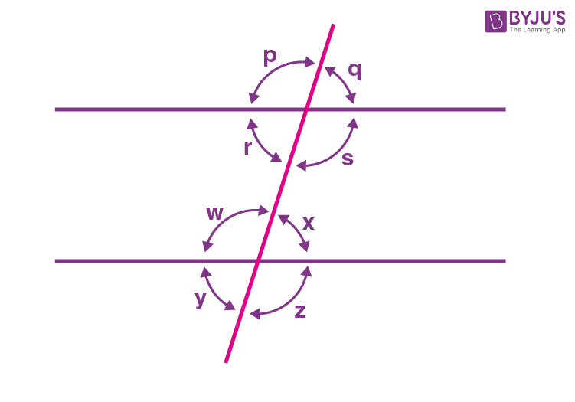

a. ∠p and ∠q
b. ∠p and ∠w
c. ∠p and ∠x
d. ∠p and ∠z
Answer: b

10) If AB || CD, EF ⊥ CD and ∠GED = 135° as per the figure given below. The value of ∠AGE is:

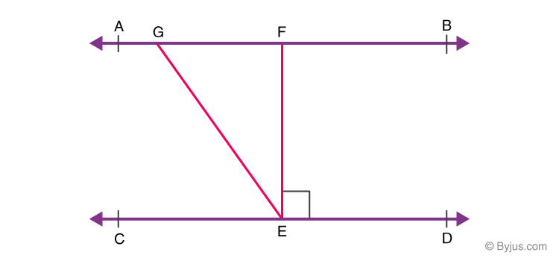

a. 120°
b. 140°
c. 90°
d. 135°
Answer: d

11) An exterior angle of a triangle is 105° and its two interior opposite angles are equal. Each of these equal angles is
(a) 37 ½°
(b) 72 ½°
(c) 75°
(d) 52 ½°
Answer: d

12) If one of the angles of a triangle is 130°, then the angle between the bisectors of the other two angles can be
(a) 50°
(b) 65°
(c) 145°
(d) 155°
Answer: d

13) If two interior angles on the same side of a transversal intersecting two parallel lines are in the ratio 2 : 3, then the greater of the two angles is:
(a) 54°
(b) 108°
(c) 120°
(d) 136°
Answer: b

14) If one angle of a triangle is equal to the sum of the other two angles, then the triangle is
(a) a right triangle
(b) an isosceles triangle
(c) an equilateral triangle
(d) an obtuse triangle
Answer: a

15) The angles of a triangle are in the ratio 5 : 3: 7. The triangle is
(a) a right triangle
(b) an acute-angled triangle
(c) an obtuse-angled triangle
(d) an isosceles triangle
Answer: b

16) Angles of a triangle are in the ratio 2: 4 : 3. The smallest angle of the triangle is
(a) 20°
(b) 40°
(c) 60°
(d) 80°
Answer: b

17) In the given figure, POQ is a line. The value of x is
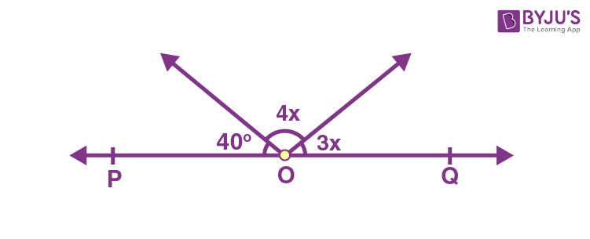

a. 20
b. 25
c. 30
d. 35
Answer: a

18) In the given figure, , if AB || CD || EF, PQ || RS, ∠RQD = 25° and ∠CQP = 60°, then ∠QRS is equal to
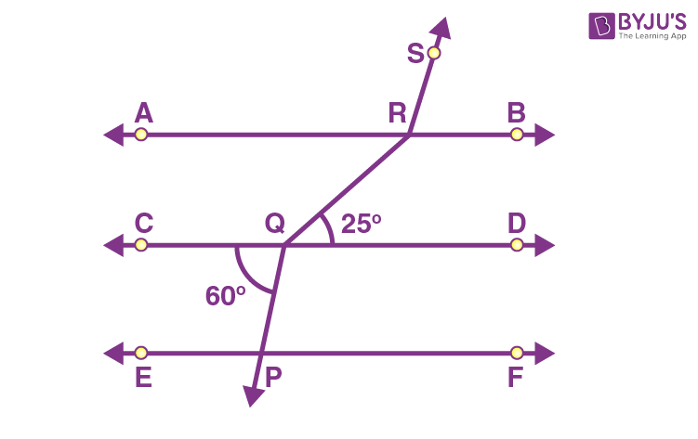

a. 85°
b. 110°
c. 135°
d. 145°
Answer: d

19) An obtuse angle is
(a) Less than 90°
(b) Greater than 90°
(c) Equal to 90°
(d) Equal to 180°
Answer: b

20) In the given figure, if OP||RS, ∠OPQ = 110° and ∠QRS = 130°, then ∠PQR is equal to
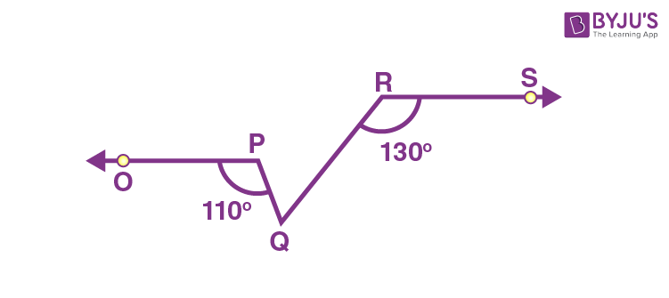

a. 40°
b. 50°
c. 60°
d. 70°
Answer: c

